**Thonburi Bamrungmuang Hospital.**

**Set up for Emergency Department , ICU Department and Cath Lab Department.**

**Chulaporn hospital**

Supervisor . Assess patient care requirement on each unit, by making rounds in the Emergency Department, and all other areas of the hospital. Act as a resource in identifying and/or solving administrative /operational problems.Report to the administrator-on-call significant incidents and problems such as.Provide for immediate follow-up, documentation and communication of incidents to appropriate manager and director.Respond to emergency situations (RRT,Code Blue) and assists as necessary.

**Bumrungrad International Hospital *As a register nurse level 3 in Radio-Onco Center.***

***IV Nurse***level 4. As a register nurse level 2 in Intervention Radiology unit and X-Ray department .Scrub in Angiogram Procedure.Manage all medical supply as physician request.

**Vichaiyut Hospital**

***Emergency Nurse***

* Perform ambulance services, pickup and drop off patients in all provinces.
* Perform vascular and non-vascular patient in Angiogram room

**Bangkok-Pattaya Hospital**

***Emergency Nurse***

* Perform ambulance services, pickup and drop off patients in all provinces.
* Perform critical and emergency care for patients.

**Lampaimat Hospital**

***Register Nurse***

* Perform nursing care for out-patients with diabetes, hypertension in PCU

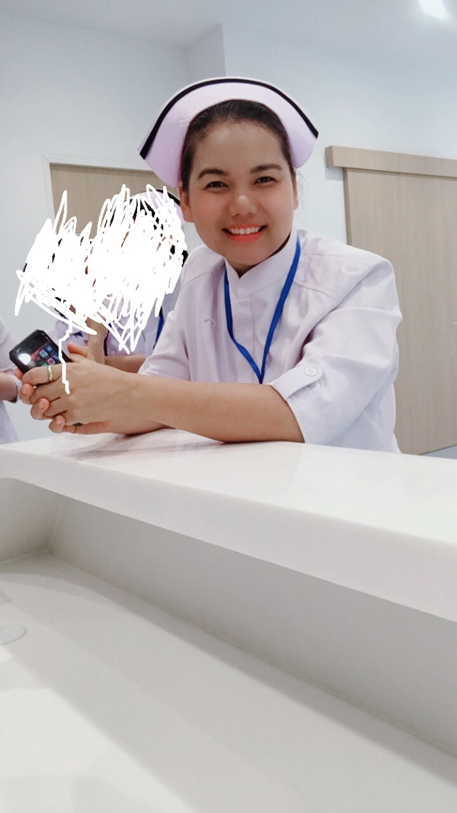

**Sep. 2018 – Present**

**Mar. 2018 -June 2018**

**Feb. 2012-Feb. 2018**

**Mar. 2008-Jan 2012**

**Mar. 2006 -Feb. 2008**

**Apr. 2004-Feb. 2006**

**EXPERIENCE**

**JIRAWAN**

**PAKKEATATI**

Register Nurse

**ABOUT ME**

Date of Birth : 06th April 1981

Nationality : Thai

Languages : Thai (mother tongue), and English (speaking, writing, reading listening)

**REFERENCES**

Assist.Prof.Dr.Chumpol Wongwanit ,Physician in Division of Vascular Surgeon

Tel: +66 9929432

**CONTACT**

33/109 Navy-house 27 Moo 9 Plutaluang Chon Buri 20180

Phone +66 61-9369566

E-mail: jpakkeatati@gmail.com

**Boromarajonani College of Nursing, Ratchaburi**

2000 - 2004

**BACHELOR OF NURSING SCIENCES**

**EDUCATION**

**LANGUAGE SKILLS**

Good

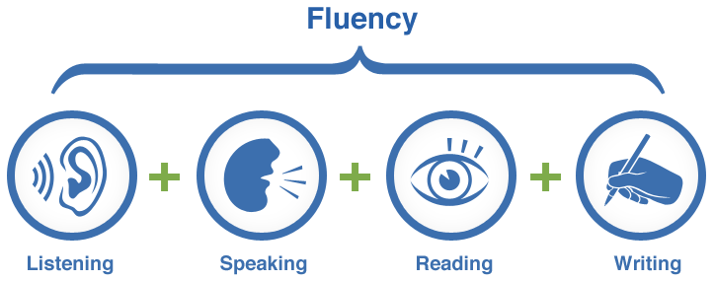

**COMPUTER AND SOFTWARE SKILLS**



**CERTIFICATE**

* Professional License in Nursing and Midwifery (First Level), given by Nursing and Midwifery Council
* Peripheral Advance Course
* ACLS
* Emergency Course
* Wound care
* Prevention to Intervention Cardiology

**TRAINING**

* Advanced Cardiac Life Support with AEDs: ACLS, organized by Phramongkutklao Hospital.
* Peripheral Advance Course.
* Update of Wound Care and Wound Healing by Rajavithi Hospital.
* Nusing care for the Elderly
* Emerging Medical Problems
* Patient Safety Program Bumrungrad International Hospital.
* Infectious Control Day Bumrungrad International Hospital
* Nov 2018 Infection prevention and control Program to prevent health care-associated sepsis through hand hygiene and infection prevention and control (IPC) action.
* Dec 2018 BLS (Basic Life Support) training Program Organized by Thonburi Bumrungmuang Hospital.
* Jan 2019 Training for ICU nurse in CPR / BLS/ACLS/AED /Defibrillator and mobile ventilator use in ambulance Organized by Thonburi Bumrungmuang Hospital.

**QUALIFICATION AND SKILL**

* 16 years’ experience as a registered nurse, working in a settings these include emergency patient care, Outpatient critical care unit and inpatient care .4 mount experience in management working as a supervisor at chulaporn hospital . 6 mount. Experience in critical care and 1 year Experience in Cath Lab department incloud about Vascular procedure and Coronary procedure at Thonburi Bamrungmuang Hospital.
* Excellent in leadership and management skills.
* Excellent interpersonal communication skills.
* Excellent planning problem-solving and Decision mature.
* Good organization skills,mature,positive and hardworking individual, who always strives to achieve the highest standard of care.