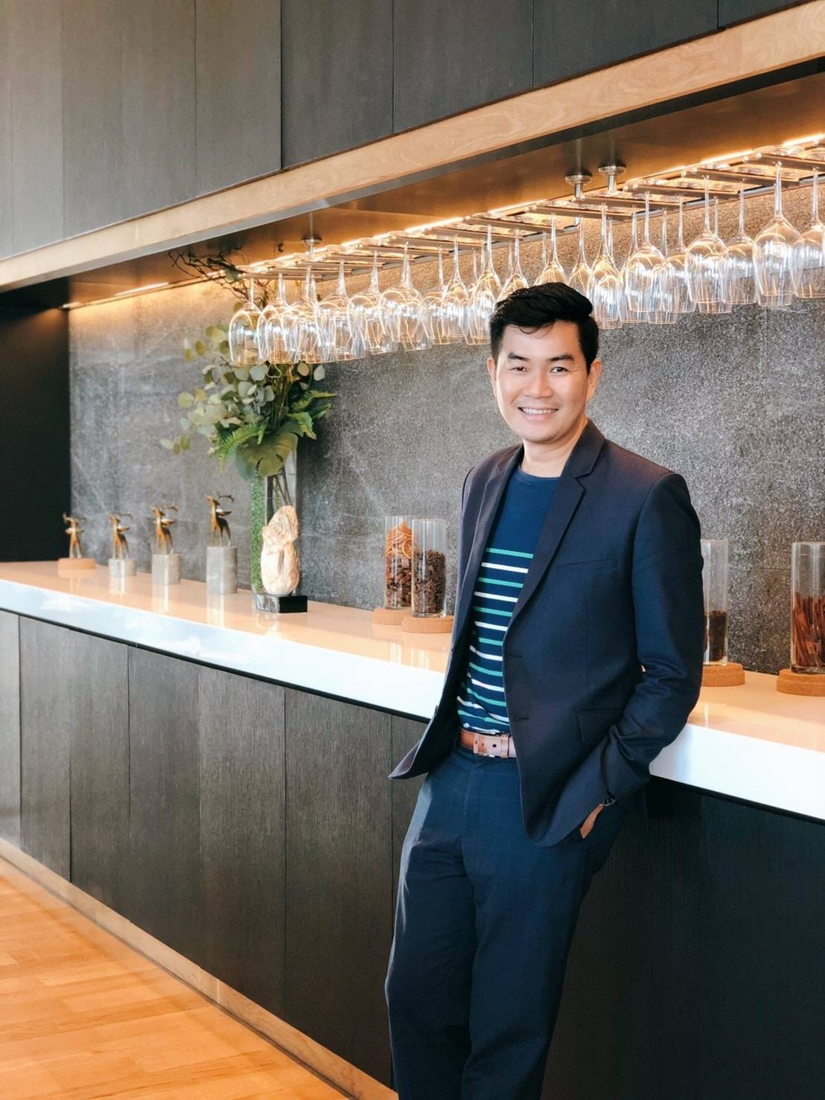
YONGYUTH SINGNON

Mobile: +66 082 9543 662 Email: y.singnon@gmail.com Line ID: yysnn

----------------------------------------------------------------------------------------------------------------------------------
OBJECTIVES: Highly experienced Marketing and Sales with far-reaching responsibilities. A 360-degree hotelier thinker and decision-maker with an extensive background in PR and communications, hotel and resort operation excellence, implemented new sales approaches to improve the results to the hotel & restaurant bottom line, broadened team focus to include overall hotel revenue, ADR and F&B contribution. Excellent record of successfully working the value chain to grow revenue.

EXPERIENCES:

Feb 2018 – Oct 2020 Director of Sales and Marketing

Gaysorn Urban Resort – The luxury co-sharing space of networking events and social functions.

Develops and analyse the premier co-sharing space's capabilities and fine dining restaurants identify the direct sales, advertising, and public relations programs necessary to attract sources of business. Implement the annual strategic sales, marketing and PR direction plan including financial/business performance vs forecasts/budget and make the required changes if necessary. Create innovative publicity programs and Maximize opportunities for publicity that will increase awareness and positive perception of the property, culinary programs, services, and personnel.

Apr 2015 to Dec 2017 Director of Sales Marketing - Food Valley Co., Ltd

Overall results from the development and execution of strategies that will support, strengthen and grow the restaurants, bars, shops operations. Oversees the restaurant general managers, shop manager within region, as well as indirectly supervising the property level staff members to meet and exceed the strategic goals of the organization. Ensures operational excellence for all restaurants, shops in portfolio; provides support, critique and guidance to hotels falling short of brand standards and/or company expectations.

Jul 2011 to Apr 2015 Resort Manager

The Sea Koh Samui Resort & Residence/Ploen Chaweng Koh Samui (Sinthoranee Property Company)

Engaged in day-to-day operations for 4-star plus resort, 46 Villas & Suites. Executes business plans designed to maximize property customer satisfaction, profitability, and market share; ensures that property business plans and employees are aligned with brand business strategies; Supervise &works closely with sales and marketing team to develop revenue generating strategies for property; identifies new business leads, develops tailored sales approach, and actively pursues leads with Sales and Marketing team; as well as managed sales & marketing for the Mother Company’s (Sinthoranee Property Company) newly-launched budget hotel chain – Ploen in Koh Samui, Pattaya and Hua Hin.

Oct 2003 to Sep 2009 Asst. Director of Public Relations and Communications

Six Senses Resorts and Spas – Head Office, Thailand

Promoted from property resort -Events and Marketing Manager to head office to be responsible for develop and execute an annual PR plan as an integral part of resort marketing plan, based on guidelines given in the annual plan instructions, including a PR roadmap, segment strategies, and key PR initiatives.

Maximize opportunities for publicity in all media through careful research and targeted editorial pitch plan, focused on key feeder markets for both the group and leisure segments. Maintain professional relationships with media to support achieving the goals outlined in the PR plan, including the distribution of targeted media releases, media kits, pitches, and other PR related material.

Mar to Aug 2001 Marketing Communications (Internship 6 months)

Green Dragon Wood Products, Hong Kong in 2001

EDUCATION:
2012: Master’s Degree of International Tourism and Hospitality Management,
Naresuan University International College, Thailand.
2010: Master’s Degree of International Tourism and Hotel Management,
Southern Cross University, Brisbane-Australia.

2005: Bachelor of Art in Business Administration,
Sukhothai Thammathirat Open University, Thailand
2003: Bachelor of Art in Business Administration,
Minor in Marketing and Communication Management,
Udonthani Rajabhat University, Thailand

LANGUAGES:

Thai - Native Speaker, English – Fluent, Japanese – marginal conversation

OTHER ABILITIES:

Hotel program: Fidelio, H.I.S. Opera, Commanche,

Microsoft Office: AI, Word, Excel, Access, Power Point,

Outlook Email etc.

Ability to type both Thai and English at 50 WPM and 50 WPM, respectively

Online advertising: Google AdWords, SEO, Google AdBanner, Social medias, social medias

REFERENCE:

Mr. Sukanan Sirivanichsuntorn, Managing Director of Food Valley Co., Ltd

Email: sukanan.s@foodvalley.co.th Mobile: 0898154590

