**Resume**

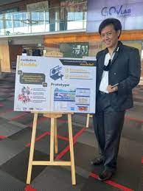

**Academic backgrounds**

Bachelor degree; Bachelor of Science in physical therapy; 2.91 [Chulalogkorn University] 2557

Master degree; Master of business administration; majoring in marketing, 3.36 [National Institute of developmental administration] (NIDA) 2564

**Work experiences**

- Research assistance (1 year)

- Freelance therapist and fitness instructors

- Pilates practitioner (1 year as freelance)

- Fitness administrator

- Marketing Executive at private hospital (half year)

**Prove of Success**

-Successor of UIF team in NIDA, 2020

-Participants in government lab 2, Department of land team

-Participants in individual project from social lab project, funded by UN.

**Language performances**

IELTS scores; overall 6.0 (at 8th June 2021)

**Interested in**

Marketing

Business development

**Further citation**

https://universityinnovation.org/wiki/Fellow:Puch_Jaroonwit