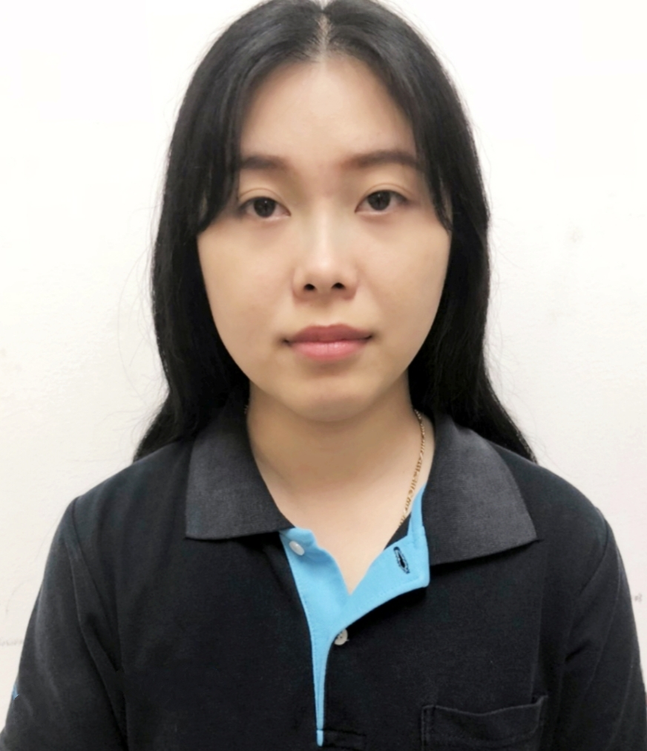

**Miss Jenjira Tricharoenwatanakul (Jane)**

**Address:** 8/1 Moo 3 Soi Boonsiri 6,Sukhumvit Road,

Bangmuang, Muang, Samutprakan 10270

**Mobile:** 083-466-9532

**Email:** [janeja111@hotmail.com](mailto:janeja111@hotmail.com)

**Personal Data**

Age : 34 Years Nationality : Thai

Marital status: Single Religion : Buddhism

Height  : 161 Cm. Weight  : 57 Kg.

|  |
| --- |
|  |

**Objective:**

My desire is to find a stable yet challenging position in a professional environment in which to learn new technologies and skills while utilizing my previous experiences to improve beyond my current abilities.

**Education**

Assumption University of Thailand 2013.

Bachelor Degree of Arts (B.A) with a major in Business English and minor in Chinese with GPA. 2.6.

**Work Experiences:**

May 2015 – August 2023

**SATO AUTO-ID (THAILAND) CO,LTD,Samutprakarn, Thailand**

Japanese company, manufacturer and distributor of barcode printer SATO brand, provides label printing and software solution in Auto-ID system.

**Position: Marketing Executive**

* To collect, analyst and generate sales or general data report to management.
* To collaborate with Suppliers in order to get a competitive buying price.
* To collaborate with Sales team for pricing quotation and support their need in Marketing.
* To collaborate with teammates i:e Sales, Sales Co-ordinator, Purchase and work toward complete the issue.
* To collaborate with government department for product licenses i:e NBTC, TISI, EXCISE etc.
* Supporting the customer’s need i:e provide letter or some document.
* Supporting Marketing work i:e prepare to set up the exhibition or event.

April 2014 - August 2014

**ITOS Corporation,Bangkok,Thailand**

The company provides medical equipment, military products, and computer solutions for financial institutions.

**Position : Account Executive**

* Responsible for full sales cycle of ITOS Corporation’s products
* Manage accounts and ensure satisfaction and proper usage of ITOS’ computer solution
* Provide support for client entertainment where appropriate
* Execute daily tasks, track progress, revise plan to ensure objectives are met
* Maintain accurate reference documentation for internal management

July 2013-April 2014

**Rakahng Associates company , Bangkok, Thailand**  
The Company provide about Training Manager Program.   
**Position: Administrative Assistant Secretary**

* Responsible for organizing trainings
* Coordinated with publisher to ensure prompt delivery of training materials
* Prepared training materials
* Made arrangement for training facilities
* Summarized training evaluations and presented to the trainer for improvement
* Served as first point of contact for potential clients
* Performed daily bookkeeping for all expenses and incomes

**Skills**

Languages THAI: Good, ENGLISH :Good

Computer Microsoft Office: PPW, Word, Excel.

Fast learner  
Flexible / Adaptable  
Patient

Friendly and Responsible

**Interest**

Reading, Music, Movie

Sport: Badminton, Swimming